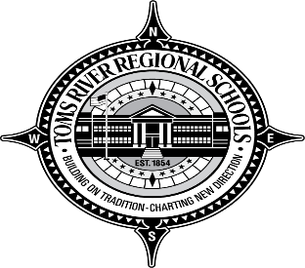 | Toms River Township Meeting

Wednesday, May 15, 2019
7 – 8:15 p.m.
Toms River HS East Student Center

Purpose: Creating a positive school culture of tolerance, acceptance, and excellence, with the goal of promoting positive race relations in the community and our schools.

Objectives:

Promoting positive race relations

Advocating for excellence and diversity in our schools.
__________________________________________________________________________________
Time: 7 – 8:15 p.m. | Topic: Promoting Positive Race Relations in the Community
Principal of TRHS East  Mrs. Casey Daniel  7 – 7:05 p.m.  Mayor of Toms River  7:05-7:15 | Welcome message and opening comments.  Importance of responsibilities, tolerance, and safety of students.  Discussion of the importance and acceptance of change and diversity
Ocean County Cultural & Heritage  Commission  7:15-7:30 p.m. | Encouraging creative and cultural expressions through inclusiveness and education, the Ocean County Cultural and Heritage Commission promotes public interest in the arts and the preservation of cultural and heritage
Toms River NAACP President  7:30-7:45 p.m.  Toms River East Character Club  Advisor and President  7:45-8 p.m.  Closing Remarks  Mayor  8-8:15 p.m. | Discussion of issues of racial inequality and how we can work together to create a culture of tolerance and acceptance.  Discussion of implementing character education lessons and a culture of tolerance.  Closing remarks and comments

