RUNNING HEAD: Needs Assessment of School Budget 1

Needs Assessment of School Budget
Casey Daniel
Grand Canyon University EAD - 510

June 12, 2019

NEEDS ASSESSMENT OF SCHOOL BUDGET 2

Introduction
Toms River Regional Schools has maintained a successful budget over the years. The district is presented with an estimated $240 million budget each year. Toms River Regional Schools Business Administrator, Mr. Bill Doerring, has successfully allocated the funding to the 25 schools and facilities throughout the district. The district effectively and efficiently allocates wages and salaries, extracurriculars, such as sports and clubs, allocation of stipends, custodial products, supplies, technology and professional development. Building Principal, Mr. Patrick Thomas discusses that his budget for Toms River East is not strict, and there is always more than enough money each year. The technology budget was reduced by ten percent, but moving forward, each year when Mr. Thomas requests money for additional items, the request is always granted. Mr. Thomas uses the program Systems 3,000 to review the budget from previous years and to maintain accurate records of the Toms River High School East budget. Through this system, he is able to review data and evidence of previous years and request adjustments to accounts and money allocations, if needed. The 2019 school year was particularly interesting for Toms River School District and community, as the district successfully passed a much needed referendum to support improvement projects throughout the district. The referendum is a major component of the 2019-2020 budget as renovations and improvements will be provided to the 25 schools and facilities throughout the district, including Toms River High School East. The total for the referendum was $12,359,572. 28 for priority 1, $27,058,708.07 for priority 2, for a grand total of $153,746, 23765 for Toms River High School East.. The biggest need for the Toms River
NEEDS ASSESSMENT OF SCHOOL BUDGET 3
Regional School district is the fight to restore state aid. The district is projected to lose 18 million over the next seven years. The district is already facing the impact from the budget cuts as staff members are receiving rift notices. The budget cuts will decimate the community of Toms River.
Overview
The budget goal for Toms River Schools is to development a financial plan to continue to support our educational program that considers losses in funding and alternative revenue sources. In reviewing data from previous years, the Board of Education, staff, and district administration successfully completed their goal and vision. The district has completed several initiatives such as reducing technology costs of over a million dollars in sponsorships and a million in grants.The Toms River Regional School District is the second largest district in the state. The district is composed of a total of 25 schools and facilities. This includes three large high school, three intermediate schools, numerous elementary schools, the central registration office, The J. Bennett Athletic Complex, maintenance and grounds, the Pine Belt Arena, and transportation and vehicle maintenance costs. The proposed district budget for the 2019-2020 school year is $242,289,201. Toms River High School East is allocated $25,188,490.01. This is broken into several sections, including salaries, cleaning repair and maintenance, media services, general supplies, textbooks, printer and ink supplies, travel expenses, copier costs, instructional equipment, athletics, and extracurricular accounts. The major impact of the budget is loss of state aid for the projected 2019-2020 school year.

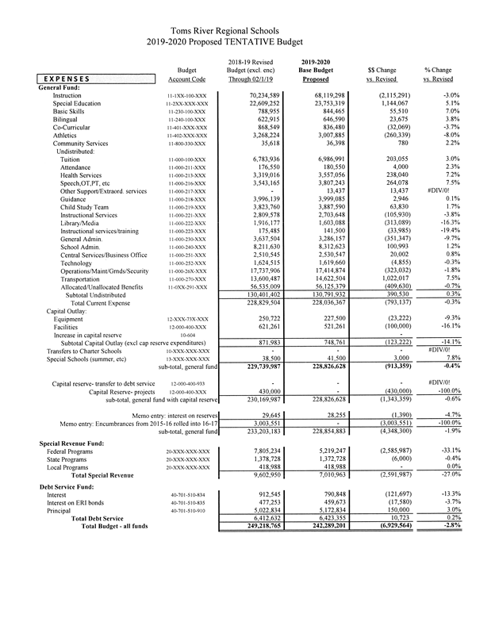
NEEDS ASSESSMENT OF SCHOOL BUDGET 5

Budget Implications
The major budget implications for the Toms River Regional School District is the loss of state aid. The projected loss of state aid will decimate the district. The Toms River Regional School District is projected to lose over $18 million over the next seven years. Toms River Schools would see a cut of $988,678 for 2018-19, and a total cut of $18,572,932 over the seven years, according to figures released by the NJ Office of Legislative Services. The implications over this loss of aid are loss of staff and increase in class sizes. With retirements for the 2018-2019 school year, to create a working budget, 58 teaching jobs will be cut, 12 secretarial jobs, six facility jobs, and one administrative position. The budget also has to eliminate 55 assistant coaching positions for sports teams. Additionally, as stated by Principal Mr. Patrick Thomas, there was a ten percent cut from accounts for general supplies and textbooks.
Plan of Action:
Toms River Schools has always been innovative in creating additional sources of income and increasing revenue. Unfortunately, even with an aggressive plan of action, without the restoration of state aid, the district will suffer. Toms River Regional Schools had conducted a series of bus trips to Trenton, letter writing campaigns to Governor Sweeney, and has actively communicated to local newspapers and news stations to get the message to the public how the budget cuts will negatively impact staff, students, and the community as a whole. Under strong leadership, and the successes of previous years, the district is still hopeful that funding will be restored. Regardless, below is a list of goals that have been successful for the district creating a
NEEDS ASSESSMENT OF SCHOOL BUDGET 6
successful budget. All information was provided from the Toms River Regional Schools Website, district goals and mission, and building principal of High School East, Mr. Patrick Thomas:
- Communications costs have been reduced (and will continue to be reduced into the future) with the implementation of a new phone service and hardware.
- RWJBarnabas Health Arena naming rights agreement was finalized for $637,000-- the largest single corporate sponsorship in the state.
- The Hirair and Anna Hovnanian sponsored facility upgrades with a $255,000 Year 1 sponsorship
- Bus and web page ad sponsors were increased.
- Nearly $1 million in competitive grants awarded to the district this year, including $763,000 from the Office of Naval Research over three years to expand computer programming opportunities $25,000 from Sustainable Jersey for environmental programs $100,000 from the EPA for energy efficient buses,
- The Energy Savings Improvement Project (ESIP) plan finalized with over $17 million in projects to be fully funded by energy savings, with no final cost to the taxpayer.
- $147 million in priority facilities projects finalized into a final referendum proposal for a public vote in the 2018-2019 school year.
- The administration and Board continued to aggressively advocate for funding at the state level, with $3.3 million restored for the 2017-2018 school year.
Current Budget Revenue
NEEDS ASSESSMENT OF SCHOOL BUDGET 6
The proposed district budget for the 2019-2020 school year is $242,289,201. Toms River High School East is allocated $25,188,490.01. The cost per pupil for the district for the proposed 2019-2020 school year is $13,611. The district is fiscally responsible with costs per pupil, classroom instruction, classroom salaries and benefits, and classroom materials.
Moving Forward & Monitoring Progress
Continue to fight to restore funding through aggressive means, while looking for ways to manage the loss of funding. Review amount of retirements and amount of staff members to be laid off, making the best decisions for the students. Review the data and projected student enrollment to reallocate funds. Keep the community involved in the fight to restore state aid, addressing the issue with taxpayers, teachers, administration, staff, and students. Continue to reach out to state officials and the governor, the importance of the state aid for the school district. The district and community is still reeling from the effects of superstorm Sandy, and the district will suffer with loss of state aid. Maintaining momentum and continued involvement in the fight to restore state aid is essential. Through the media coverage, Superintendent David Healy and Business Administrator Bill Doerring were able to meet with state officials and the governor. The district implemented a letter writing campaign and delivered over 30,000 to the state officials, stating how the budget cuts will decimate the community of Toms River Schools. The district continues to use the momentum and the positive effects of social media to send tweets to officials stressing the importance of their education and the funding.
Conclusion:

NEEDS ASSESSMENT OF SCHOOL BUDGET 7
The district is actively and aggressively attempting to restore the state funding, while implementing various ways to create additional revenue and offset the loss of state aid. The projected loss for 2019-2020 school year is 2.8 million. If the district continues their fight to restore funding, there could be a potential restoration in years to come. All major educational stakeholders are involved, including, state officials, superintendents, media, administration, staff, students, parents, and community members. With the projected loss of state aid to the Toms River Schools Budget, High School East is directly impacted and will need to continue to address the improvement plan, budget goals, and decisions made for the students in the next seven years.

